Experiment: 6
5G NR Frame Structure Analysis with Different Subcarrier Spacing
Objectives
1. To analyze different Subcarrier Spacing (SCS) values used in 5G NR numerology.
MATLAB Program
clc;
clear;
close all;

scs = [15 30 60 120 240]; % Subcarrier Spacing (kHz)
mu = 0:4; % Numerology Index
bar(scs)
grid on
set(gca,'XTick',1:5)
set(gca,'XTickLabel',mu)
xlabel('Numerology Index (\mu)')
ylabel('Subcarrier Spacing (kHz)')
title('5G NR Subcarrier Spacing for Different Numerologies')

OUTPUT:
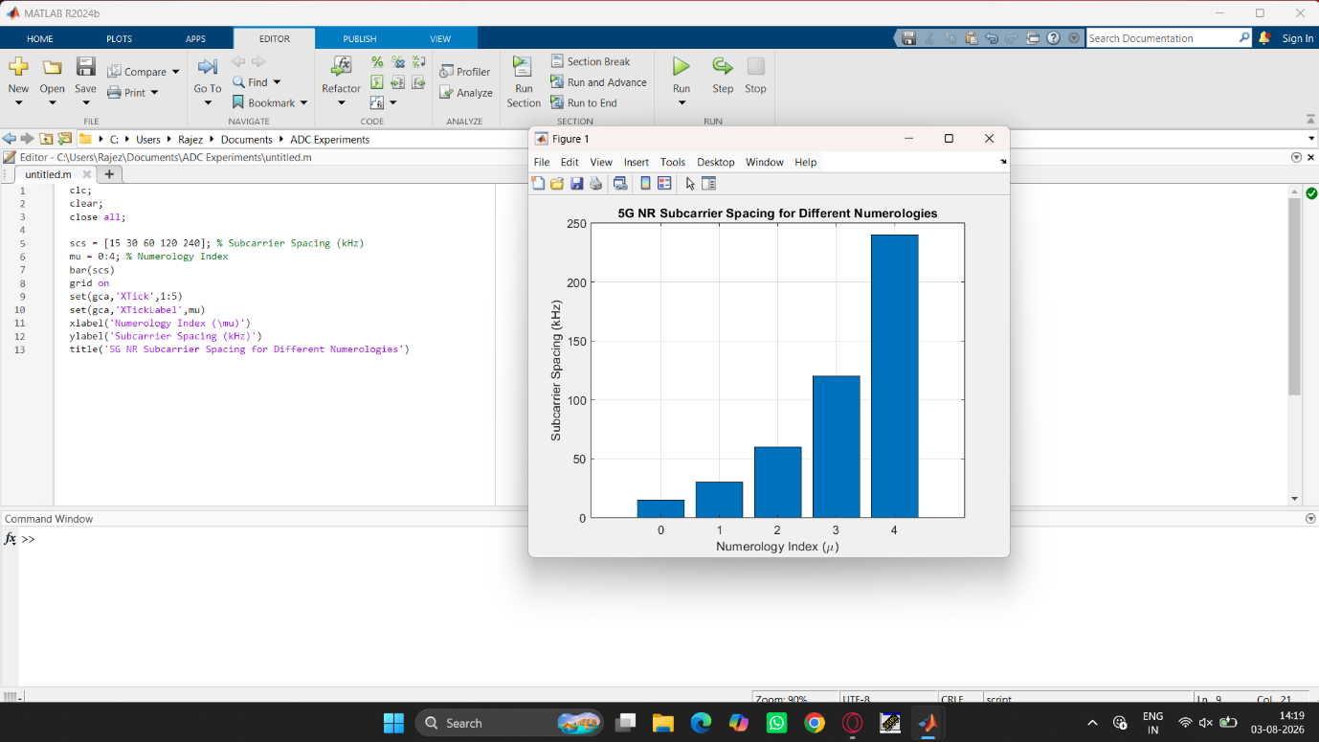

Objectives
2. To compare the slot duration corresponding to different Subcarrier Spacing values in 5G NR.
MATLAB Program
clear;
close all;
scs = [15 30 60 120 240]; % Subcarrier Spacing (kHz)
slot = [1 0.5 0.25 0.125 0.0625]; % Slot Duration (ms)
plot(scs, slot, 'o-', 'LineWidth', 2)
grid on
xlabel('Subcarrier Spacing (kHz)')
ylabel('Slot Duration (ms)')
title('5G NR Slot Duration for Different Subcarrier Spacing')

OUTPUT:
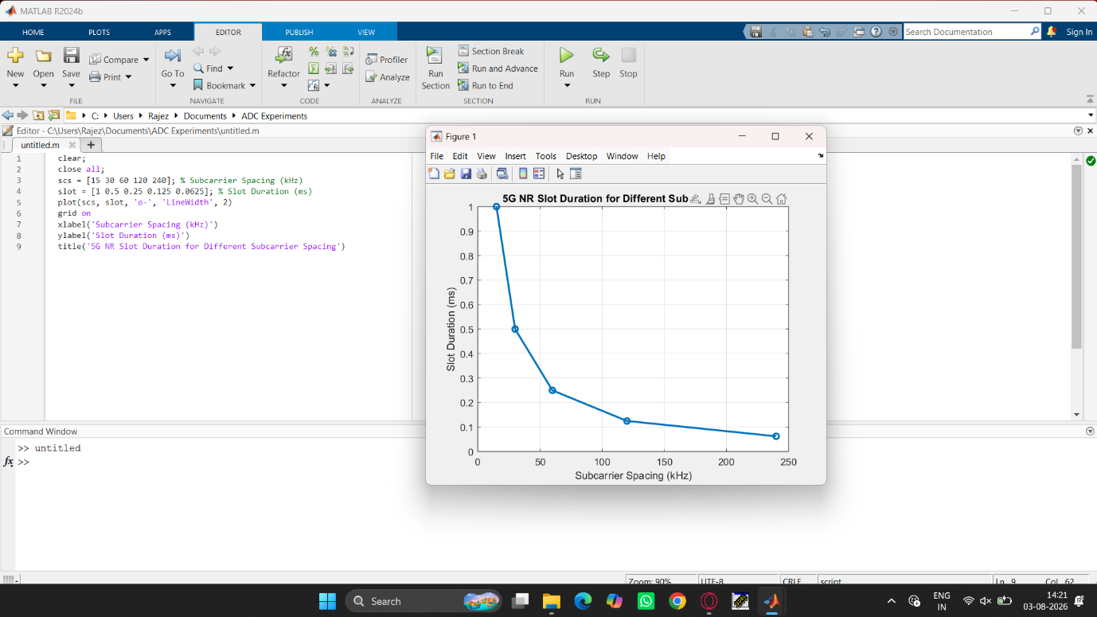

Objectives
3. To study the number of OFDM symbols present in a 5G NR slot for normal cyclic prefix.
MATLAB Program
clc;
clear;
close all;
scs = [15 30 60 120 240]; % Subcarrier Spacing (kHz)
symbols = [14 14 14 14 14]; % OFDM Symbols per Slot
figure
bar(scs, symbols)
grid on
xlabel('Subcarrier Spacing (kHz)')
ylabel('Number of OFDM Symbols')
title('OFDM Symbols per Slot for Different Subcarrier Spacing')
ylim([0 16])
OUTPUT:
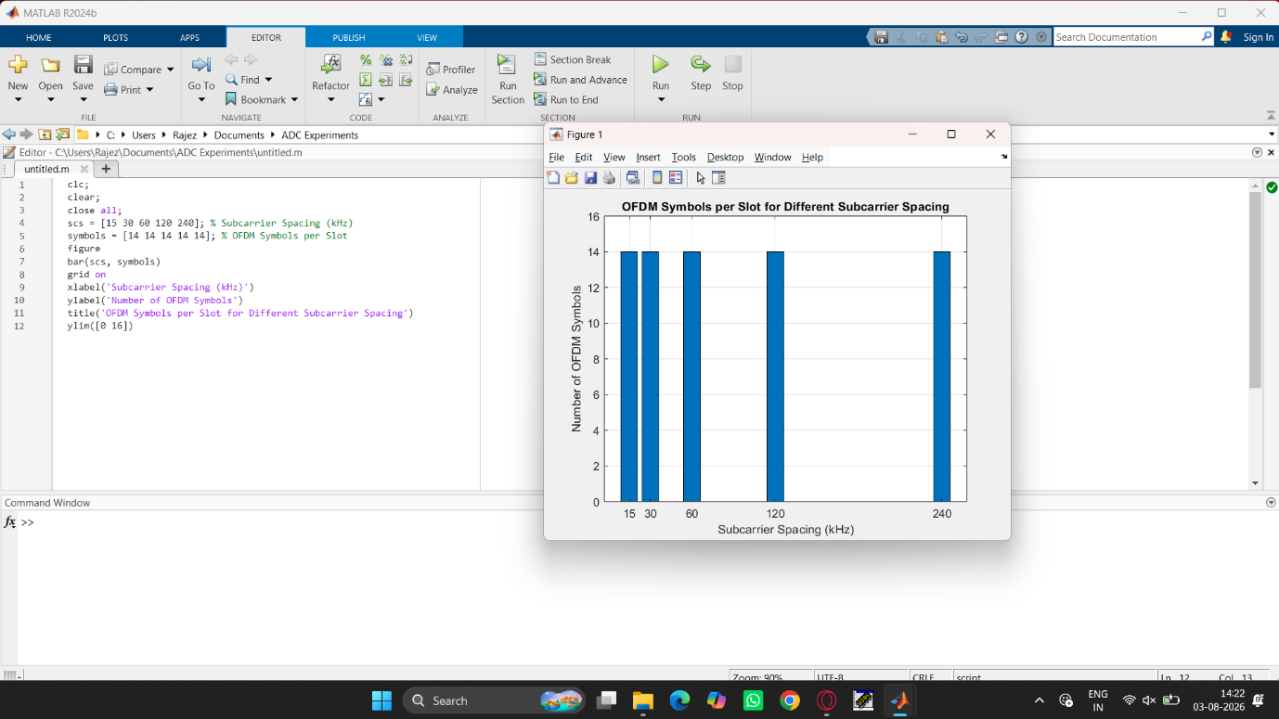

RESULT:
The MATLAB analysis successfully demonstrated the flexible numerology of 5G NR. The results showed that increasing the subcarrier spacing decreases the slot duration while maintaining a constant number of OFDM symbols per slot under the normal cyclic prefix configuration.

